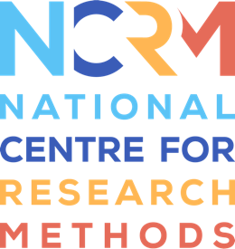
Event history - analysis using retrospective partnership data

Event history analysis using STATA
Full resource, see: https://www.ncrm.ac.uk/resources/online/all/?id=20861

1 event of interest
Video 2 shows an example of how to apply event history analysis to fertility data to study the transition to a single event. This is also sometimes called survival analysis where “survival” is not experiencing the event and “failure” is experiencing the event. Below is the code that can be used for the Harmonised Histories, accompanying Video 2. The example used is the event of having a first birth.
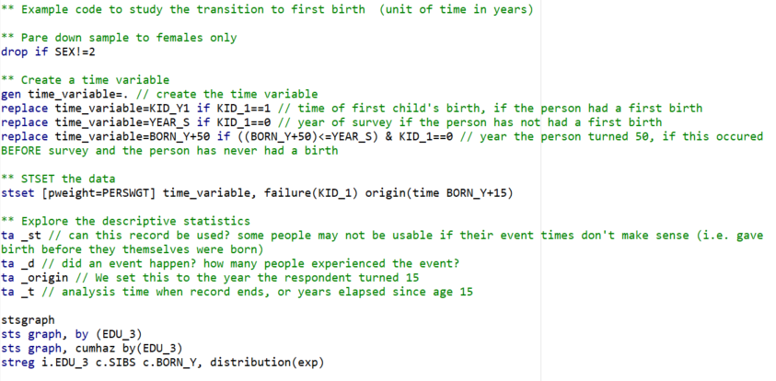

Event history analysis using STATA

Two events of interest, competing risks analysis
Video 3 shows an example of how to apply event history analysis to a case where there are two events of interest which compete with each other. We use the example of marriage and separation as two competing events within a first partnership. Below is the code that can be used for the partnership data in the Harmonised Histories, accompanying Video 3. The example shows the transition to either marriage or separation, among those in their first partnership.
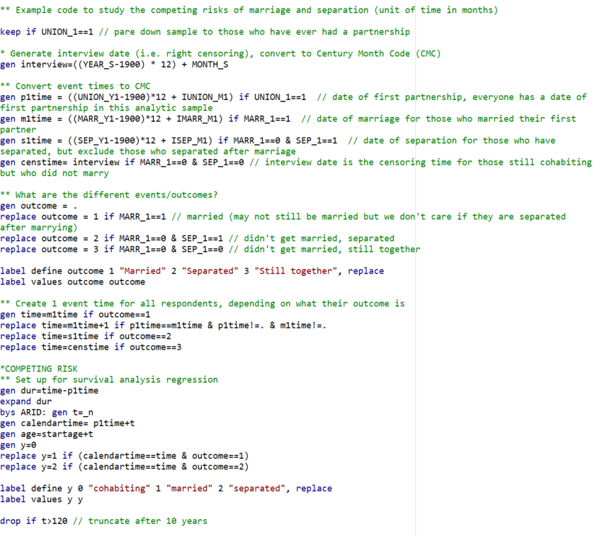

National Centre for Research Methods (NCRM)
Social Sciences
Murray Building (Bldg 58)
University of Southampton
Southampton SO17 1BJ
United Kingdom
Web www.ncrm.ac.uk
Email info@ncrm.ac.uk
Tel +44 23 8059 4539
Twitter @NCRMUK

